**Keerthi koushik devulapally**

**Nikhil reddy jitta**

**Ranjith reddy pingli**

**Neelima vuyyuru**

LOST IN THE WOODS

**Introduction**

In this passage I would like to state about the game “Wandering in the woods “which I am developing. Over here I have mentioned the requirements that are required to build a program. Then for help I have ta. This full design has to be defined first in the software architecture when there is availability of new data. The tools that are required to make a game should be mentioned properly. In this passage of report writing I have mentioned the requirements of the game. This report is like a blueprint of the program. I have to attach paperwork as well as a framework for future purposes. For making a proper game feedback is quite essential. For future improvement these papers are essential as in these papers I would like to mention the tools that were used.

This game which I have built specially for the children in school. This game will help the student to grow mentally. Through the stages of the game that are inbuilt by solving the stages of the game, the personality of the respective child will also grow. The child will also feel confident after completing all the stages of the game. The report which I am making is both for the users as well as the developers of the game.

“Wandering in the woods” is basically divided into many grades for students. The students who are in between the grades three to grade five are almost like beginners. So in this grade the students are associated with little data as the beginners will not be able to handle an excess amount of data. Another grade system is between the grade six to grade eight is that in this grade the students are more likely to explore their mental strength by solving the stages of the game. This solving of grades will help the student in their future or deal with problems. For testing purpose the game should be conducted between two students to get a desired result.

**Process Model:**

Process Model in the architecture means that it allows the organization to see what are requirements required for business purposes. The policies that have already been made for the betterment of selling the program. Most of the game developers follow the agile methods for making the game as it is the standard one that is available in the market in this modern era. The main purpose of the game is to grow the mental health of the student. In this game interactive sessions are there where the students can get the knowledge. An Evolutionary development model was introduced which basically determines how the game works . This EDO was introduced to meet the demands. The main purpose of the EDO is that with lower cost they can attract more and more students. In this process with low risk the capacity of the production should be increased. When the development of the game is midway some modification requests are bound to come. As these are the requirements of the client so features had to be given in the program. As the requirements keeps on changing so the model has to be maintained well.

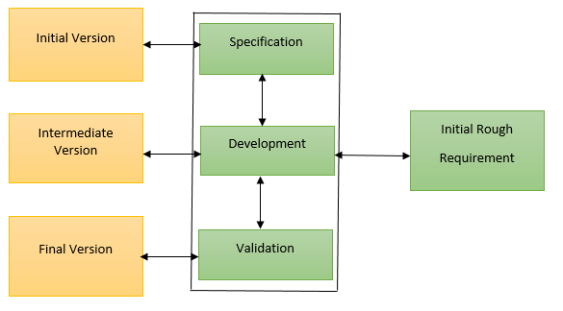

**Evolutionary Process model for a system**

**Use Case:**

In Use Case specific goals are being set. In this User Case the game is made by consulting with the user. Basically in the system the point of view of the user is depicted. Every user has a different point of view and they are not related to another. At the start of every process the user has mentioned the task that is to be achieved and at last the task will be completed. In this process it is also seen how a system would react when I use the use case. In this task the complexity of the system is calculated .By executing this process a list is created where the number of tasks that need to be performed are mentioned. As soon as the project is confirmed by the team then the functions can be selected. The design is made in such a way that the things that are being picked by the developers can be easily spotted. The use case denotes that the things that are picked are important and thongs are going to be implemented by the developer. The main thing in this process is the design that the developers make.

**Use Case 1:** It is the start of the game. The User Case id is 1. The student here starts the game. The actor in this case is the student. Installation is done by the student as it is a new game. At first the student will open the game then they will click on the homepage of the game. After coming to the home the student will click on the start option that is present in the screen.

**Use Case 2:**  The User Case id is 2. In this step the student will play the game and the grid paged will be moved by the user. .The actor in this case is the student. From the menu option in the game the student will select the option. The game will be selected from the option of the screen. The game will be started. Then play option will come on the screen. The grid line will be displayed on the screen. Then at last the student will start playing.

**Use Case 3:**  The User Case id is 3.In this the student will choose grades according to the individual students. The actor in this case is the student. In this process the student will select the stage. IN this case the student will select the screen. After selecting the screen the game will start. Then selection of stage will be done by the student. Then play option will appear on the screen. The grid line will be displayed on the screen. Then at last the student will select the stage.

**Use Case 4:**  The User Case id is 4.The actor is student in this case is the student. In this step the student can see the statistics. As the game is played the students can see the characteristics according to the playing. The actor in this case is the student. The game is for students. In this the student will first select the screen. After selecting the screen the student will start the game. The student will select the grade option. After selecting the grade the student will select play option. hen on the screen grid line will be displayed. Then the game will be started by the student. During the playing of the game statistics will be displayed. These statistics will be displayed on the screen over a period of time.

**Use Case 5:**  The User Case id is 5.The actor is student in this case is the student. In this step the student the replay of the game that will be played on the screen a number of times. The student should play the game for their benefits. The student should select the screen then the game will start. Selection of grades is necessary for playing . The grid line will be displayed and the game will start playing. Then full details statistics will be displayed on the screen. On the screen the student will replay the game. The reply opinion will be selected by the student.

**Use Case 6:**  The User Case id is 6.The actor is student in this case. When the game will end the student will select the exit option. The student should be in the home page of the game. After selecting the screen then the game will start. After starting the game then immediately the student will exit the game. Then again in the next step the student will play the game and after playing the student will exit the game. After playing the game then the student will exit the game as also the window.

**Use Case 7:**  The User Case id is 7. In this pattern the student starts to move diagonally. That is in the opposite direction. The actor in this step is a K-2 group student. The game should be started by the student. K-2 group students will play the game. The student should be in the home page of the game. After selecting the screen then the game will start. Play option will appear on the screen. Grid will be displayed and the student will move diagonally in the opposite direction. When the screen will be shared by two students then there will be happy emoji displayed on the screen. After this the game will restart again .From the statistics we can get the number of moves made by the student. In the graphics of the system the music can also be heard.

**Use Case 8:**  The User Case id is 8. In this step the size of the grid is to be altered by the student. Here the actors are from grade K3-5 students and from grade K 6-8 students. grade K3-5 students or from grade K 6-8 students will start the proceedings of the game. The student should be in the home page of the game. After selecting the screen then the game will start. Play options will be selected by the student. In the screen the grid line will be displayed and the student will alter the grid line. Then the two students will meet with each other then happy emoji will be displayed on the screen then the game will be restarted by the system. From the statistics we can get the number of moves made by the student. According to input given by the students the grid changes.

**Use Case 9:**  The User Case id is 9.Here the actors are from grade K 3-5 students and from grade K 6-8 students. The student will alter the size of the grid.K3-5 students or from grade K 6-8 students will start the proceedings of the game. The student should be in the home page of the game. After selecting the screen then the game will start. When the student will select the play option then the grid line will be displayed on the screen and this grid lines will be changed by the student. The student will be moving in any direction. Then the two students will meet with each other then happy emoji will be displayed on the screen then the game will be restarted by the system. From the statistics we can get the number of moves made by the student. According to input given by the students the grid changes.

**Use Case 10:**  The User Case id is 10. In this process the system will provide new challenges to the program. In this group K6-8 group students are present. The students from this group K6-8 will start the proceeding of the game. The student selects the home page and then starts the game then the student will select the play option. When the student selects the play option then the grid line will be displayed on the screen and these grid lines will be changed by the student. Then the movement of the student is in any direction .Then the two students will meet with each other than happy emoji will be displayed on the screen then the game will be restarted by the system. From the statistics the number of movement students can be calculated.

**Use Case 11:**  The User Case id is 11.In this step different methods will be tried by the students in different cases. In this group K6-8 group students are present. The students from this group K6-8 will start the proceeding of the game. The student selects the home page and then starts the game then the student will select the play option. When the student selects the play option then the grid line will be displayed on the screen and these grid lines will be changed by the student. Then the movement of the student is in any direction .Then the two students will meet with each other than happy emoji will be displayed on the screen then the game will be restarted by the system. From the statistics we can get the number of moves made by the student. According to input given by the students the grid changes.

**UML Model:**

UML stands for Unified Modeling Language. UML is a visual language that helps to understand the design that the developer has made. In this field it acts like a blueprint of the game.

**Usage case Diagram:** In use case diagram UML is used. UML is used to analyze the various steps that are required to design the game. The requirements that are coming to the developer consists of both the external as well as internal which can influence the developer.. The information regarding the development of the game is depicted in the chart. One who goes through the chart can clearly relate the development that has been done. In this diagram high level functions are being used. This figure also helps to point out the interaction that has been done.

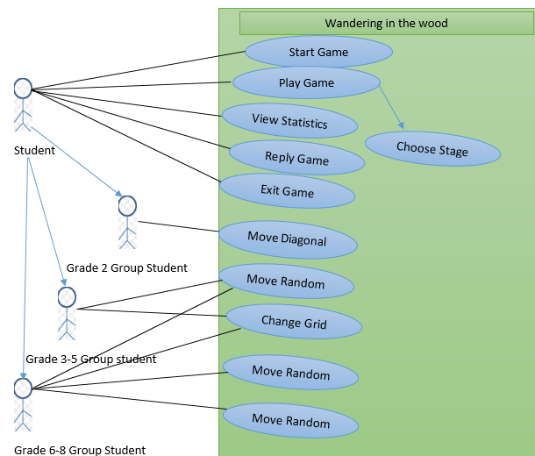

**Use case diagram for a system.**

**Deployment Diagram:** In deployment diagram the user case basically shows the hardware materials that are associated with the system. All the conversation process and the software files are presented in the hardware of the system. Deployment diagram is the physical architecture of the game model. It also shows what is the relation between the hardware of the system and the software of the system. It also shows the physical distribution that is there in the game as shown in the figure below.The game will be made with the help of java language as java has the best connectivity in the market.In this case apache server is being used. The main work of this server is to collect the response from the user.The application server is connected by the sql to the database .In the database the data is stored

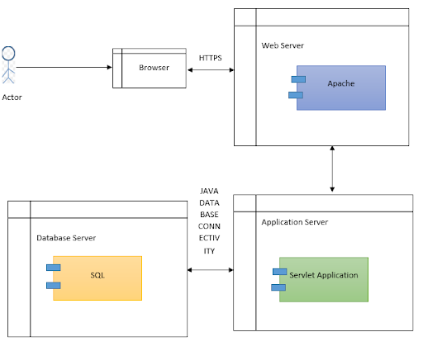

**Deployment Diagram**

**Class diagram :** Class diagram is nothing but the diagram of statistics.The application view can be denoted by the class diagram. In this class diagram as a student they can get both the visual representation as well as documentation . This expansion of the system also can be done as writing of code in the software is also possible in this step.There are three stages associated with the game.

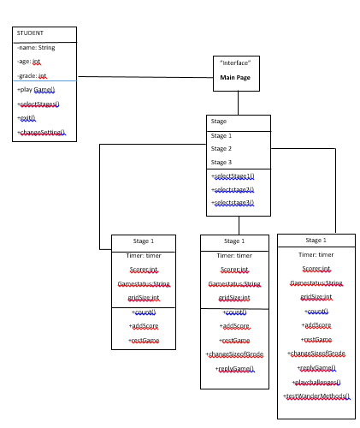

**Class diagram of a system**

**Description of classes :** Student class comes first . Then with student class the attributes are also attached with it.Then the name of the person should be initialized. The name should be of sting type.Then age of the student should be initialized .The value should be of integer.Then garde of the student is initialized. Grade is an integer value.

Operation: Then comes the operation .In these functions that are related to the program are demonstrated.

”Playgame()” : The function of the play game.

” Selectstage()” : The function of the select stages in the game.

” Exit()” :The exit function of the game

.” ChangeSettings()” denotes the change of settings of the game.

Stages(Attributes):

Stage 1 : In this stage information is stored about stage 1.

Stage 2 : In this stage information is stored about stage 2.

Stage 3 : In this stage information is stored about stage 3.

Operations: Then comes the operation .In these functions that are related to the program are demonstrated.

“ SelectStage1() “ : Function of the stage 1 of the game.

“ SelectStage2() “ : Function of the stage 2 of the game.

“ SelectStage3() “ : Function of the stage 3 of the game.

Stage 1(Attributes ):

Timer : Total movement of the time of the individual student.

Score : Total score of the individual student.

Gamestatus : The status of the game is shown.

Stage 1 (Operations):

Count ():It counts the Functions .

Addscore(): It add the score

Reset Game(): It reset the game.

Stage 2 (Attributes):

Timer : Total movement of the time of the individual student.

Score : Total score of the individual student.

Gamestatus : The status of the game is shown.

Stage 2 (Operations):

Count ():It counts the Functions .

Addscore(): It add the score

Reset Game(): It reset the game.

Changesize(): It changes the size of the grid .

Replaygame() : It replays the game.

Stage 3 (Attributes):

Timer : Total movement of the time of the individual student.

Score : Total score of the individual student.

Gamestatus : The status of the game is shown.

Stage 2 (Attributes):

Timer : Total movement of the time of the individual student.

Score : Total score of the individual student.

Gamestatus : The status of the game is shown.

Stage 3 (Operations):

Count ():It counts the Functions .

Addscore(): It add the score

Reset Game(): It reset the game.

Changesize(): It changes the size of the grid .

Replaygame() : It replays the game.

Play Challenge(): It denotes new challenges(6-8 group students).

Testwandermethods() : Ot denotes different methods of wandering.

**State Diagram :**

State Diagram state of the system. In the diagram below it shows the behavioral diagram. It is a chart diagram.It denotes the changing of external stimuli over a period of time .In this diagram it denotes the three steps associated with it.At first the game will be in “Ready” state. Then after some time the option changes to the “Play “ state.If the student wants to pause the game then the “Pause “ option is selected..Then again the student wants to resume the game “Resume” option selected. When the student wants to quit the game then student will the select the “End” option.

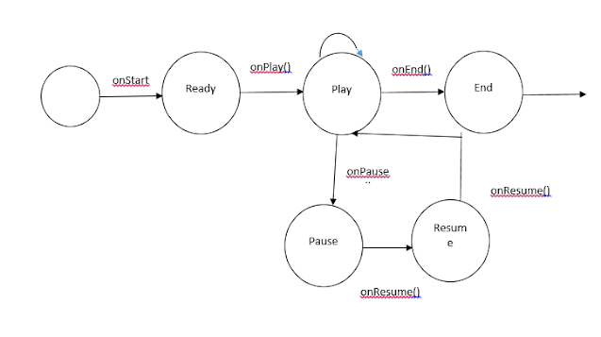

**State diagram of the system**

**Activity Diagram :**It basically explains the Dynamic aspects of the diagram.It is flowchart representation . In this flowchart it basically explained the functions of the flowchart.When the user wants to start the game then we have to select the correct option to start the game.Sometimes the settings are changed then the user will move back to the main page of the flowchart.At the end if the user wins the challenge the music will be played.

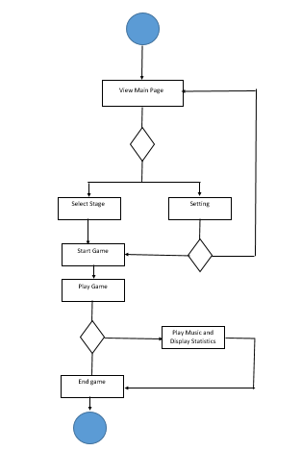

**User Journey Map :**

In this map it states how the interaction is going on with work that I have put in .A perfect businessman can easily guess the requirements that the user asked by simply looking at their eyes.The feedback of users are important as they help to improve the product.It is the bond that is created between the user and the developers.A developer can easily understand the the requirements of the user.The requirements can easily meet the ideas which help the developers to show their skills

**Personas:**

In this case the designers can show their skills.Here what the different user wants that is shown. Here their priorities are given a thought and act according to it.A proper analysis is done on this step.A student who is in grade 8 is not a strong candidate.Thta student likes to play the game. For this reason many help that student to gain the grade.Here new challenges are associated with it.